APPLICATION FOR THE ERECTION OF THREE DETACHED DWELLINGS ON LAND AT WINDMILL FARM, SILVER HILL, HURST GREEN.

PLANNING STATEMENT.

Graham Fifield
GRF Planning
30 Collington Avenue
Bexhill on Sea
East Sussex
TN39 3NE

Tel: 01424 221225
Email: graham@grfplanning.com

Introduction

This report relates to an application for three detached dwellings on land adjacent to Windmill Farm, Silverhill, Hurst Green. Although in outline with all matters reserved, apart from the means of access it is accompanied by illustrative drawings showing an indicative layout and elevations. This statement will describe the site and its relationship to its surroundings, the relevant planning policies both at local and national level and the presumption in favour of the proposal given the lack of a five year supply of housing land in Rother District.

The Site

Silver Hill is situated some 1.2km to the south of Hurst Green and comprises a modest, but cohesive cluster of dwellings alongside the A21 and Bodiam Road. There is a footpath along the A21 to the village and an hourly bus service (304/305) Monday to Saturday to Battle, Hastings and Tunbridge Wells. The application site is situated on the west side of Bodiam Road. It lies immediately to the north of Windmill Farm which is a substantial modern property and effectively defines the southern boundary of development on the western side of Silver Hill. The application site is irregularly shaped and extends to some 0.3 hectares and is approximately rectangular in area. To the west is the A21. The site is at a higher level than the road, but well screened from it. The proposed dwellings are set well back from the A21 and owing to this, the topography and existing vegetation would not be visible from it. The land generally falls from east to west, although that part on which the dwellings would be sited is generally level. The land then rises before falling to the west. There are a number of rather derelict buildings on the site together with two caravans previously used for residential purposes. These will all be removed if the development took place. The caravans will be commented upon later in this report. The dwellings, or at least their upper parts, will be visible from Bodiam Road, but a strong belt of planting behind the visibility splay will “soften” their appearance. Photographs of the site and its surroundings are below.
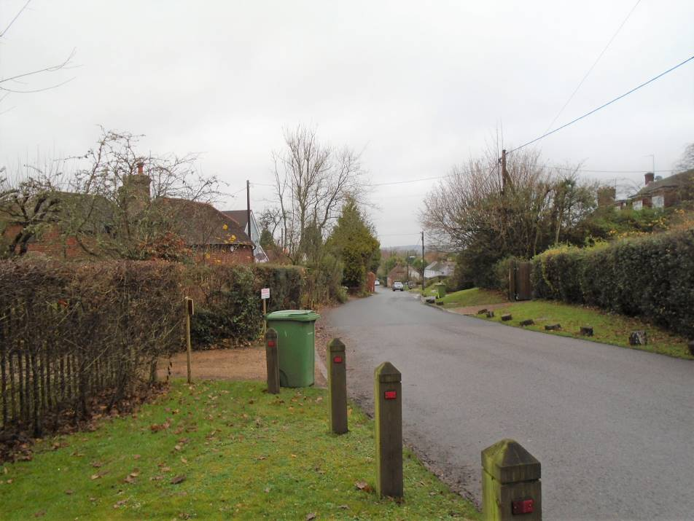
Looking north along Bodiam Road from northern end of site
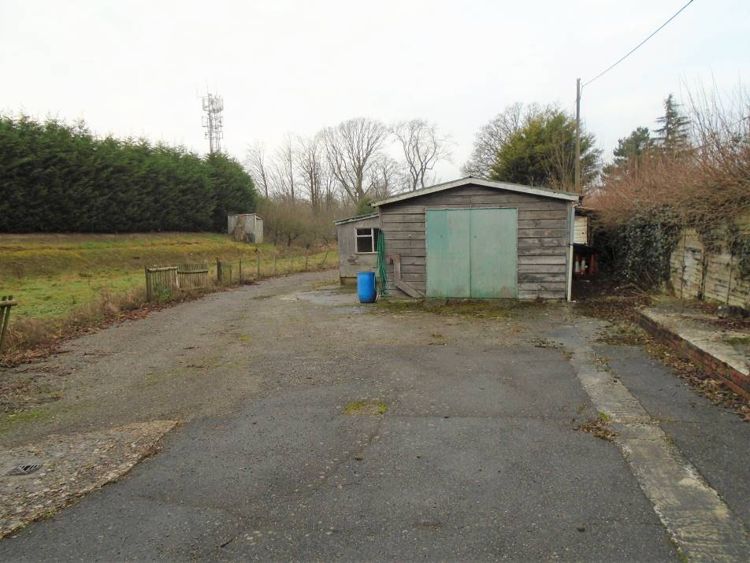
View north west from southern boundary
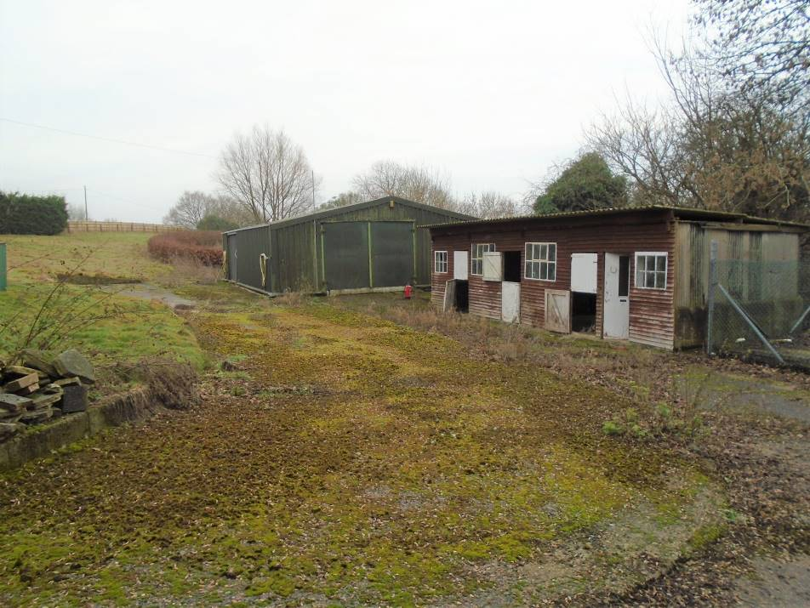
View south from northern end of site
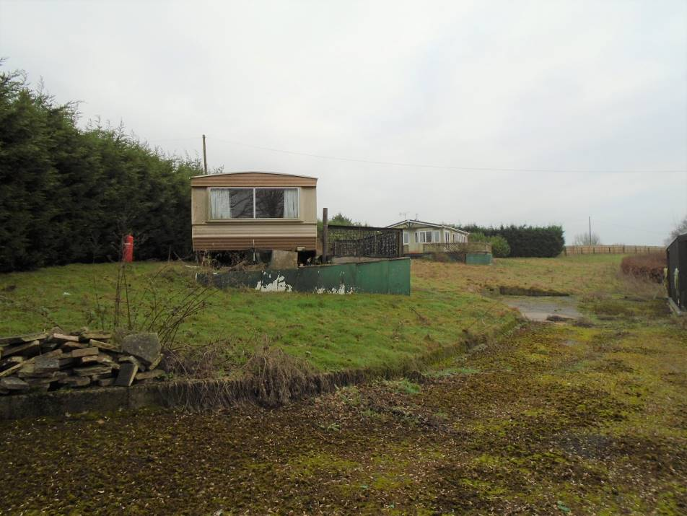
View south east from within the site
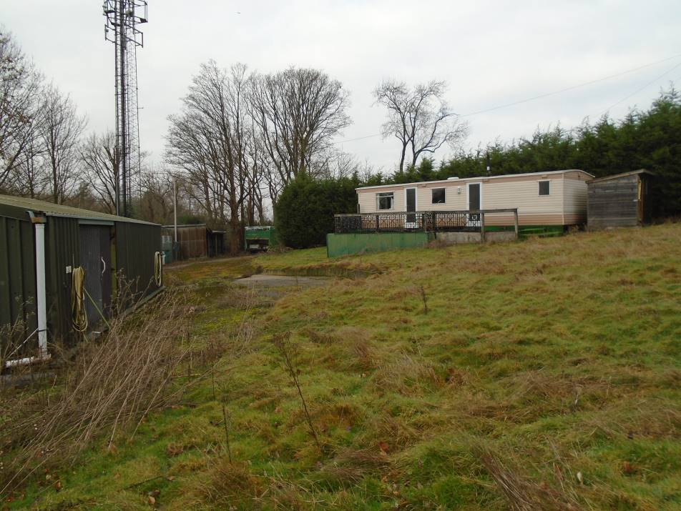
View north from within the site

Relevant Planning History

RR/2006/69/P was an application for a change of use to residential for one gypsy family with two mobiles and one tourer caravan. The application was refused, but subsequently allowed on appeal. Amongst other matters, the Inspector concluded that the development had very little impact on the wider area and there would be no material impact on the landscape quality of the AONB. Permission was granted for a limited period and subsequently renewed twice in 2011 and 2016. RR/2007/3343/O granted a LDC for a static caravan for residential purposes. This is not the subject of any limitations and would be removed together with the other caravan and all the unsightly structures.

Planning Policies

Rother District Local Plan 2006

The majority of the policies in the Plan have not been saved following the adoption of the Core Strategy 2014. “Saved” Policy DS3 indicates that the existing settlement pattern will be maintained and that the majority of all new development will take place within the development boundaries of existing towns and villages as defined on the Proposals Map. At present it is only the main village of Hurst Green to the north that has a development boundary.

Core Strategy 2014

Policy PC1 indicates that when considering development proposals, a positive approach that reflects the presumption in favour of sustainable development contained in the National Planning Policy Framework (NPPF) will be taken. It also refers to planning applications which accord with the policies in the Local Plan being dealt with promptly and approved unless material considerations indicate otherwise. Account will be taken of whether policies are up-to-date, having regard to most recent monitoring information, as well as policies of the NPPF.

Policy OSS1 contains the overall spatial development strategy for the district. It provides for at least 5,700 dwellings (net) in the district over the period 2011-2028. Policy RA1 amplifies this figure in respect of the villages. It provides for a total of 1,670 additional dwellings over the Plan period. Table 12 contains the distribution of rural housing allocations and indicates that Hurst Green will provide 75 new sites.

Policy OSS2 refers to the use of development boundaries and the fact that they will continue to be used to differentiate between areas where most forms of new development would be acceptable and where they would not. It indicates that existing development boundaries will be reviewed by the Development and Site Allocations DPD, having regard to a number of criteria. These include (i) the existing pattern, form and function of settlements; (ii) character and settings of individual towns and villages; (iii) sensitivity to further development both within the main built up confines and in more rural fringes; and (vi) avoiding scattered and ribbon development.

The location of development is the subject of policy OSS3. Amongst other matters the character and qualities of the landscape will be considered as well as the deliverability of development.

Policy OSS4 contains the general development considerations and includes the requirement for development not to unreasonably harm the amenities of adjoining properties and to respect the character and appearance of the locality.

Policy EN1 relates to landscape stewardship and requires the protection and wherever possible enhancement of the landscape character of the High Weald AONB.

Policy CO6 relates to Community Safety. It indicates that all development should avoid prejudice to road and/or pedestrian safety. Policy TR3 relates to access and new development. Amongst other matters it seeks to ensure that new development should ensure adequate, safe access arrangements.

Development and Site Allocations Plan

This has been the subject of an examination so therefore carries some weight. Insofar as development boundaries and site allocations, there are none in Hurst Green as the Parish has been designated a Neighbourhood Area and the Parish is currently producing a Neighbourhood Plan. Policy DEN2 seeks to ensure the conservation and seeks to enhance the AONB landscape and indicates that within such areas development should be small in scale. Major development will only be permitted in exceptional circumstances. Policy DIM2 relates to development boundaries and indicates that new development will be focused within defined development boundaries and in the countryside, outside development boundaries, development will normally be limited to that which accords with specific Local Plan Policies or that for which a countryside location is demonstrated to be necessary. Policy OVE1 relates to housing supply and delivery pending plans. It states that until such times as a Neighbourhood Plan for the relevant settlement with an outstanding Core Strategy is in force, planning applications will be considered favourably where they contribute to meeting the housing target for that settlement and accords with the relevant spatial strategy and the site and development proposals are otherwise suitable having regard to other relevant policies of the Core Strategy including OSS2 and 3. This issue will be considered further under the heading of the Neighbourhood Plan.

Hurst Green Neighbourhood Plan

On 8 June 2017 Hurst Green Parish was designated as a Neighbourhood Area. The Parish subsequently put out a “call for sites” and the land at Windmill Farm was put forward as a possible housing site. The Site Options and Assessment document was published in April 2019. Insofar as the application site is concerned (site HG 38) it has not been put forward as a suitable site. The report considered that it was outside and remote from the settlement and poorly located in respect of services and facilities. It also stated that there was medium landscape sensitivity with a balance between the AONB designation and the current brownfield use. Unfortunately the assessment did not note that application RR/2006/69/P had been allowed on appeal and renewed twice. It also failed to note the comments of the Inspector regarding the effect on the AONB. In paragraph 5.17 of the assessment it also refers to the fact that if the Housing Needs Assessment identifies a local need for housing in Silverhill the site could be re-categorised as potentially suitable. Given these omissions and comments it is clear that the site could be allocated in the future. The fact that it could be re-categorised must lead to the conclusion that the decision not to include it must have been a very marginal decision and excluded some important considerations.

In the context of the Site Options and Assessment document it only identifies three sites that between them could give rise to between 9 and 33 dwellings being provided during the plan period. This is well below the Core Strategy figure of 75 new dwellings.

National Planning Policy Framework

Paragraph 7 states that the purpose of the planning system is to contribute to the achievement of sustainable development. Paragraph 8 states that there are three dimensions to sustainable development: economic, social and environmental. These give rise for the need for the planning system to perform a number of roles. The economic role includes the requirement to build a strong, responsive and competitive economy by ensuring that sufficient land of the right type is available in the right places and at the right time to support growth and innovation. The social role is met by a number of matters including the provision of the supply of housing to meet the needs of present and future generations. The environmental role is met by protecting and enhancing the natural, built and historic environment.

Paragraph 11 describes the presumption in favour of sustainable development. This is split into two sections. The first relates to plan making, the second to decision taking. With regard to the latter, it advises that development that accords with an up-to-date development plan should be approved without delay. It further advises that when the policies which are most important for determining the application are out of date, permission should be granted, unless the application of the policies of the Framework that protect areas or assets of particular importance provide a clear reason for refusing the development proposed, or any adverse impacts of doing so would significantly and demonstrably outweigh the benefits, when assessed against the policies of the Framework taken as a whole. Footnote 6 refers to areas or assets of particular importance including AONB’s. Footnote 7 refers to policies being out of date where an application involves the provision of housing where the local planning authority cannot demonstrate a five year supply of deliverable housing.

Paragraphs 78 and 79 refer to rural housing. They indicate that to promote sustainable development in rural areas, housing should be located where it would enhance or maintain the viability of rural communities. Planning policies should identify opportunities for villages to grow and thrive, especially where this will support local services. Where there are groups of smaller settlements, development in one village may support services in a village nearby. The advice is that decisions should avoid isolated homes in the countryside save in a limited number of circumstances. These two paragraphs replace paragraph 55 of the earlier version of the NPPF in virtually identical form and will be commented upon later in this report.

With regard to development in AONB’s, paragraph 172 indicates that great weight should be given to conserving landscape and scenic beauty. It also refers to planning permission being refused for major development in such areas except in exceptional circumstances and where it can be demonstrated that they are in the public interest. This proposal is not for major development.

Section 9 of the Framework relates to promoting sustainable transport. Paragraph 103 makes the point that opportunities to maximize sustainable transport solutions will vary between urban and rural areas, which should be taken into account in both plan-making and decision-taking. Paragraph 109 states that development should only be prevented or refused on highway grounds if there would be an unacceptable impact on highway safety, or the residual cumulative impacts on the road network would be severe.

Reference was made earlier to paragraphs 78 and 79 of the Framework in the context of rural housing and the similar wording to the superseded paragraph 55. That earlier paragraph was very recently the subject of detailed scrutiny in the Court of Appeal in the case of Braintree District Council and SoS for C&LG and Granville Developments ([2017] EWCHC 2743). This upheld an earlier High Court decision regarding the interpretation of what constituted isolated homes in the countryside. The judgment did not focus solely on that issue, but considered the whole of paragraph 55. It is considered very relevant to this application. It concerned the provision of housing outside a development boundary where the LPA could not identify a five year housing land supply. The main issues to arise from the judgement, in the context of the current application were:
- Paragraph 55 of the NPPF indicates to authorities how they ought to go about achieving the aim stated at the beginning of paragraph 55, namely to promote sustainable development in rural areas. It does not set specific tests or criteria by which to judge the acceptability of particular proposals. The use of the word “avoid” in the third sentence of paragraph 55 indicated a general principle, not a hard-edged presumption.
- The policy saw a possible benefit of developing housing in a rural settlement with no, or relatively few, services of its own. It simply differentiated between the development of housing within a settlement or villages and new dwellings that would be isolated in the sense of being separate or remote from a settlement.
- A settlement would not necessarily exclude a hamlet or cluster of dwellings, without, for example a shop or post office of its own or public transport within easy reach. Paragraph 55 does not stipulate that to be a village a settlement must have any services of its own, let alone “services” of any specified kind.
- The policy in paragraph 29 (now 103) of the NPPF recognized that “different policies and measures will be required in different communities and opportunities to maximize sustainable transport solutions will vary from urban to rural area”.
It is quite clear that to provide rural housing, the solutions will vary from location to location depending on local circumstances.

The Current Housing Supply Situation

The latest report relating to this is the Local Plan Monitoring Report which set out the situation as at 1 October 2018. This concluded that there was only a 3.9 years supply including a 20% buffer. As a result of this the development boundaries and other policies relating to the supply of housing land are out of date for the purposes of paragraph 11 of the NPPF.

Planning Considerations

As was described in the previous section, the development boundaries are out of date. It is therefore considered that the fact that the site is outside the development boundary for Hurst Green is not a reason in itself for resisting development. In accordance with paragraph 11 of the NPPF, planning permission should be granted unless any adverse impacts of doing so would significantly and demonstrably outweigh the benefits when assessed against the policies in the Framework taken as a whole, or specific policies in this Framework indicate development should be restricted.

With regard to the location of the development, it lies between existing development in Silverhill close to the village which has an hourly bus service as was described earlier. The site is well located in relation to other development. The northern boundary would, for example, be adjacent to Sherbrook Cottage with Windmill Farm to the south. Because of the topography and vegetation the site will not be visible from the A21 or in the wider landscape to the west. There will be limited views from Bodiam Road, but these will be very localized and screened by the proposed planting. The development will integrate well into the street scene. In accordance with the principles set out in the Braintree case, it will provide additional dwellings in what should be regarded as a hamlet or cluster of dwellings that comprises Silver Hill. The development will involve the removal of unsightly buildings and caravans, one of the latter which can be occupied for unrestricted residential use. In terms of numbers of residential units on the site it will only represent an increase of two. It is not considered that the development would have a harmful effect on the AONB. Indeed, given that the whole of Hurst Green is within the AONB it is inevitable that all the proposed 75 dwellings proposed in the Core Strategy will be within it.

Policy EN1 of the Core Strategy does not preclude development in such areas but requires the protection and wherever possible enhancement of the landscape character of the High Weald AONB. Similarly paragraph 172 of the NPPF requires great weight to be given to conserving landscape and scenic beauty, but does not preclude development. The proposal is not for major development, so does not need to demonstrate exceptional circumstances and being in the public interest. The site is not isolated from Silver Hill and indeed relates well to it.

There is a pond to the west of the development site. An ecological survey has been commissioned which has been submitted with the application. This confirms that subject to appropriately worded conditions the development will not cause any harm to protected species.

The final issue to consider is the effect on highway safety. The site lies within a 40mph speed limit. In accordance with MfS2 visibility of 2.4 x 90m should be achieved in either direction. The submitted drawings show that this can be achieved. To limit the effect of the removal of the hedge, dense planting is proposed behind the visibility splays.

Conclusion

The lack of a five year land supply results in the Development Boundaries contained in the 2006 Local Plan being out of date. It has been demonstrated that there will be no harm to the AONB. The Braintree case is considered important in how former paragraph 55, now 78 and 79 of the NPPF should be interpreted and supports the current application. The development will contribute a modest addition to the need for housing. The Neighbourhood Plan Site Options and Assessment document has not identified the 75 dwellings required by the Core Strategy and does not rule out the site being allocated. It is therefore hoped that the application will be supported.

August 2019

